Module 4) CSS and CSS 3

**Q.1:-What are the benefits of using CSS?**

**Ans:-**There are many advantages of using CSS which are as follows:

* Using CSS reduces the code of html page so that it doesn’t take much load and runs faster.
* By Using CSS also provides a better experience to user as CSS not only makes web pages easier to create but also user friendly.
* Using CSS reduces code so that it takes less time to create documents than html which saves time.
* By using Class id selectors in CSS, any changes to the HTML document format can be done easily.
* Using animations in CSS allows elements to be rendered in more than one style at once.

•

**Q.2:-What are the disadvantages of CSS?**

**Ans:-**While there are many benefits of using CSS, but it also have some disadvantages as follows:

There are many problems with using CSS such as it often confuses the user and for beginners, CSS proves to be more difficult than html.

With CSS, what works with one browser might not always work with another. The web developers need to test for compatibility, running the program across multiple browsers. There exists a scarcity of security.

1) Limited security.

2) Extra work for developers.

3) Positioning of Design Elements.

4) Takes time to formet.

5) Confusion due to many CSS levels.

6) Cross-Browser Issues.

**Q.3:-What is the difference between CSS2 and CSS3?**

**Ans:-** Following are the main differences between CSS2 and CSS3:-

* Both CSS2 and CSS3 are versions with CSS2 being the old version and CSS3 being the new version.
* Properties is higher in CSS3 than CSS2.
* There were issues with CSS2 was not fully supporting web browsers , but CSS3 is support almost all recent browsers.
* In CSS2, the options for styling were limited and in the old design, whereas in CSS3, it has been updated and added additional styling options and its design has also been updated.
* CSS2 does not support to the Responsive Design while CSS3 supports Responsive Design. Responsive is very important for creating a website.

**Q.4:- Name a few CSS style components.**

**Ans:-**There are many types of style components in CSS, some of them are as follows :-

**.1.// Selectors :-**

Any element can be easily styled by using CSS selectors.

There are many types of selectors in CSS, some of them are as follows :-

* **Universal selector.**
* **Group selector.**
* **Element selector.**
* **Class selector.**
* **I’d selector.**

•

**2.// Property and Values :-**

CSS properties are the styles used on specified selectors.

**Values:** Which defines property or values allocate for properties.

* **Display:flex** **:-** flex direction…..
* **Margin :-** Top, bottom, right, left.
* **Padding:-** Top, bottom, right, left.
* **Justify-content :-** center, space evenly, Space evenly, space around.

**Q. 5 :- What do you understand by CSS opacity?**

**Ans:-** CSS opacity is also called transparency. CSS Opacity sets the level of transparency for any elements.

Opacity is the degree to which content behind an element is hidden, and is the opposite of transparency.

Opacity value can be given from 0.0 to 1. Where 1 is not transparent at all, 0.5 is 50% transparent and 0 is fully transparent.

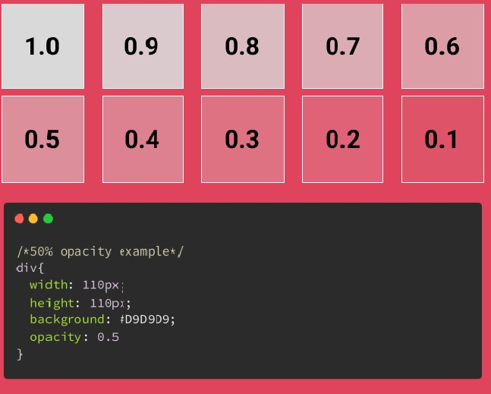

**Q**. **6 :-**  **How can the background color of an element be changed?**

**Ans:-** There are many ways to change the background color of an element in CSS.

* The first way is to change the background color of any element by giving the style attribute in the opening tag of the tag using inline CSS.

**Ex :-**

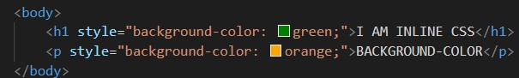

* Another way is to change the element's background color using CSS selectors like class, id, group, etc.

**Ex:-**

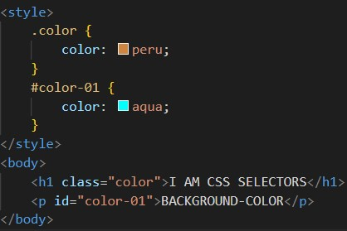

**Q. 7 :- How can image repetition of the backup be controlled?**

**Ans:-**  The background-repeat property in CSS is used to repeat the background image both horizontally and vertically.To control the repetition of an image in the background, use the background-repeat property. You can use no-repeat value for the background-repeat property if you do not want to repeat an image, in this case, the image will display only once.

repeat: This property is used to repeat the background image both horizontally and vertically.

repeat-x: This property is used to repeat the background image horizontally.

repeat-y: This property is used to set the background image repeated only vertically.

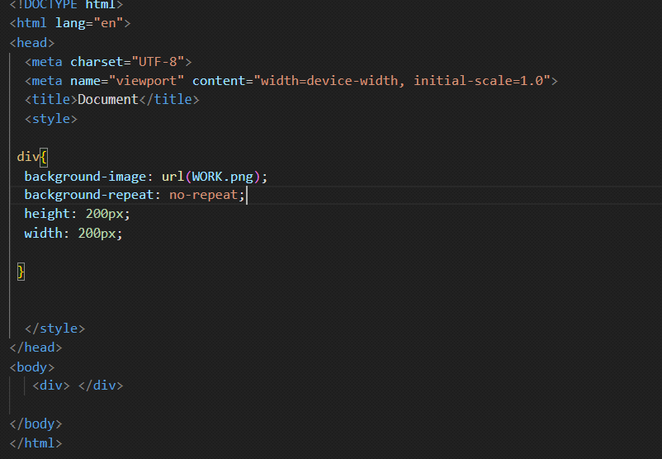

**Q. 8 :- What is the use of the background-position property?**

**Ans :-** The background position property sets the startinge position of the background image.

The position of the background image is in the top-left corner of the element by default and also repeats both vertically and horizontally.

# Ex:-

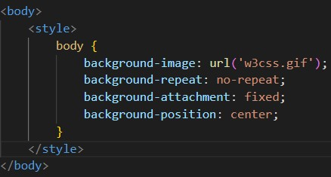

**The background-position property can have the following values:-**

1. *left top*
2. *left center*
3. *left bottom*
4. *right top*
5. *right center*
6. *right bottom*
7. *center top*
8. *center center*
9. *center bottom*

**Q. 9 :- Which property controls the image scroll in the background?**

**Ans :-** The Background-attachment property controls the scrolling of the image in the background.

When the user slides the scroll-bar of the page, the background- attachment gets a clear idea of what value is given in .

Only two values can be given in the background-attachment property.

* **Fixed :-** By specifying a background-attachment : fixed ; to the background image, the image will remain there when the content above the background image is scrolled through the scroll bar. It will not scroll with the content.
* **Scroll :-** By specifying a background-attachment : scroll ; on the background image, the image will also be scroll with content when the content above the background image is scrolled through the scroll bar. It is by default.

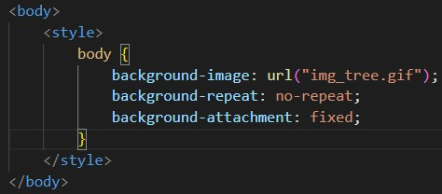

**Q. 10 :- Why should background and color be used as separate properties?**

**Ane :-** There are two main reasons why both background and color are used as separate properties.

* By using background and color as a separate property, it increases the legibility of the style sheet and makes it more attractive.
* Since background is a complex property, including it in color property increases its complexity. Beginners face some difficulty in understanding and using it
* Background and color are separate properties because they can be used for different purposes. The background property is used to set the background color or image of an element, while the color property is used to set the text color of that element. These properties can be used together to create a cohesive design, but they can also be used separately to create different effects.
* For example, you might want to set a background color for an element but leave the text color as the default.
* The CSS color is used to change the text color of a html element. In this example "This is my text" would be red. The CSS background-color is used to change the background color so in this case you would get a black box with red text inside it.

**Q. 11 :- How to center block elements using CSS1?**

**Ans :-** By using the *Center* tag in CSS1, block elements can be centered.

An update to CSS3 has added some properties to center block elements.

However, the easiest way to bring block elements into the center is to use *center tag *.

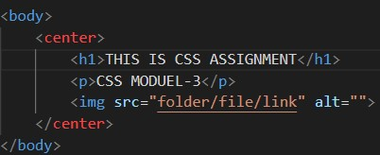

**Q**. **12 :- How to maintain the CSS specifications?**

**Ans** **:-**  To maintain CSS specifications effectively, you can follow these simple guidelines with HTML and CSS code examples:

1. **Use Clear and Descriptive Class Names:**

* Use meaningful class names that describe the purpose of the styles.
* Keep class names consistent and organized.

Image

**2. Separate Styles into External CSS Files:**

* Create an external CSS file for your styles (e.g., styles.css) to keep them organized.

Image

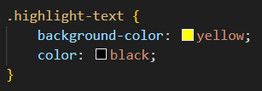

**3. Group Related Styles:**

* Group styles together for elements with similar properties.

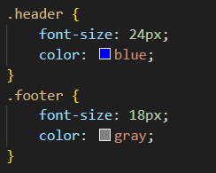

**4. Use Comments for Clarity:**

* Add comments to your CSS code to explain the purpose of specific styles.

**5.Create a Style Guide:**

* Develop a style guide or documentation that documents your CSS specifications and usage guidelines.

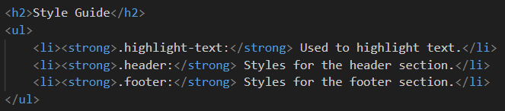

**6. Regularly Review and Refactor:**

* Periodically review your CSS code to identify redundant or unused styles.
* Refactor your code to remove unnecessary styles and improve readability.

**7. Use Version Control:**

* Use version control systems like Git to track changes to your CSS files. This helps with collaboration and version history

**Q. 13 :- What are the ways to integrate CSS as a web page?**

**Ans :-** There are three ways to integrate CSS as a web page as following.

* **Inline CSS.**
* **Internal CSS.**
* **External CSS.**

Let’s discuss the above types in detail:-

* **Inline CSS :-** Inline CSS is used only for specific/single elements. This CSS is used to give the elements a unique style. Inline CSS works by adding a style attribute to any related element. The style attribute can contain any CSS property.

**Ex:-**

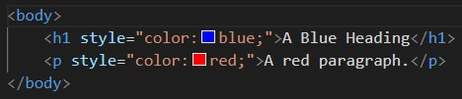

* **Internal CSS :-** A single Html page can be uniquely styled through internal CSS. Internal CSS is provided in the head section of the style element.

**Ex:-**

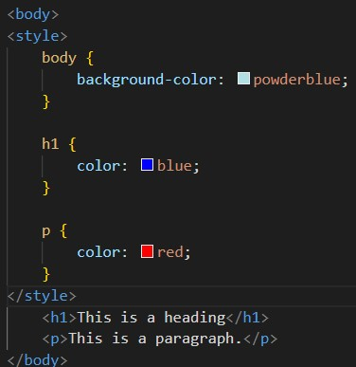

* **External CSS :-** Through this CSS, more than one html pages can be given unique style at the same time. External CSS is always defined by the link element which is given in the head section.

**Ex:-**

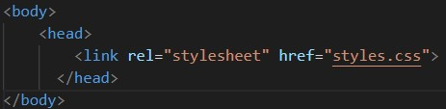

**Q. 14 :- What is embedded style sheets?**

**Ans :-** Internal style sheet is also called embedded style sheet.

A single Html page can be uniquely styled through internal CSS. Internal CSS is provided in the head section of the style element.

Internal CSS is a form of CSS using which you can add CSS to HTML documents. It helps to design the layout of a single HTML web page and change the styles of a web page within HTML code.

Internal CSS can be applied to the whole web page but not on multiple web pages and you can style several web pages by using the same code on every page.

**Q. 15 :- What are the external style sheets?**

**Ans :-** An external style sheet is a file with a .css extension that contains cascading style sheet (CSS) definitions for a webpage/webpages. It completely separates the CSS styles from the HTML document making it easy to reuse and maintain.

Through this CSS, more than one html pages can be given unique style at the same time. External CSS is always defined by the link element which is given in the head section.

External CSS styles are stored in a separate file and can be linked to multiple HTML documents, allowing for global styling across the entire website.

**Q. 16 :- What are the advantages and disadvantages of using external style sheets?**

**Ans :-**

**advantages :**

1) Faster page loading: Because the style rules are stored in a separate file, the browser can cache that file and load it more quickly when a user visits multiple pages on your site.

2) one change to the style sheet will change all linked pages.

3) With the help of External Style Sheets, the styles of numerous documents can be organized from one single file.

4) In External Style Sheets, Classes can be made for use on numerous HTML element types in many forms of the site.

5) In complex contexts, Methods like selector and grouping can be implemented to apply styles.

**disadvantages :**

1) Dependency on the file: If the external style sheet file is deleted or moved, your website's styling will be affected.

2) Less flexibility: With an internal style sheet, you can target specific elements on a page using inline styles. This is not possible with an external style sheet.

3) The execution of the file may be deferred till the external style sheet is loaded.

4) While implementing style sheets, we need to test Web pages with multiple browsers in order to check compatibility issues.

5) There might be cross-browser issues while using CSS.

1. **17 :- What is the meaning of the CSS selector?**

**Ans :-** The CSS selector is the first part of the CSS rules. It is a pattern of elements. That tell the browser which HTML elements should be selected to have the CSS property values inside the rule applied to them.

Elements can be styled differently in CSS. CSS provides some selectors to give this style. By using them which the elements can be given any style. Elements can be easily styled using CSS selectors.

**Class Selector :** The .class selector selects elements with a specific class attribute. To select elements with a specific class, write a period (.) character, followed by the name of the class. You can also specify that only specific HTML elements should be affected by a class.

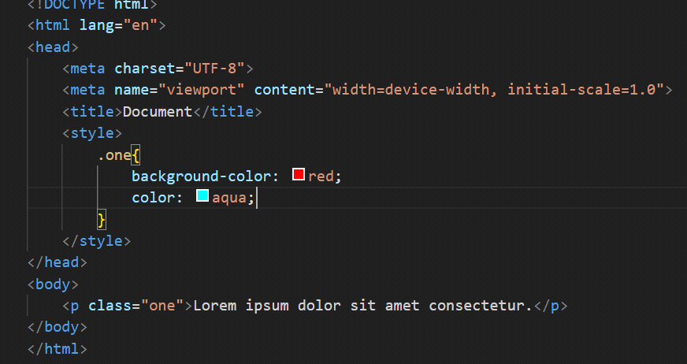

**ID Selector :** An ID selector begins with a # rather than a dot character, but is used in the same way as a class selector. However, an ID can be used only once per page, and elements can only have a single id value applied to them. It can select an element that has the id set on it, and you can precede the ID with a type selector to only target the element if both the element and ID match.

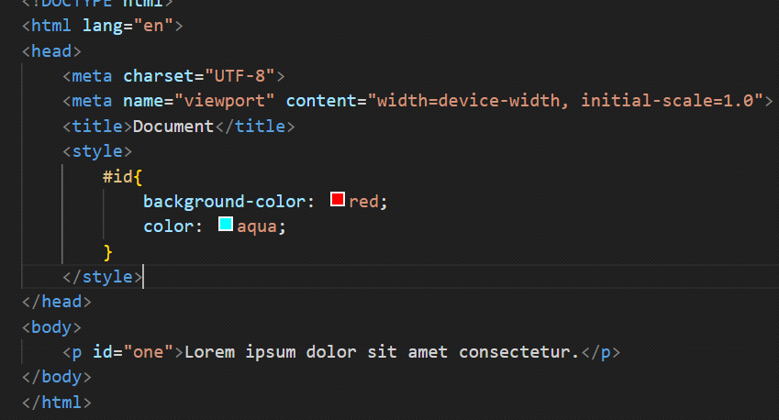

**Pseudo Class Selectoer :**  CSS pseudo-classes are used to add styles to selectors, but only when those selectors meet certain conditions. A pseudo class is expressed by adding a colon (:) after a selector in CSS, followed by a pseudo-class such as "hover", "focus", "active"," visited","first-child",or,"nath-child"

The :current CSS pseudo-class selector is a time-dimensional pseudo-class that represents an element or the ancestor of an element that is currently being displayed. For example, this pseudo-class can be used to represent a video that is being displayed with captions by WebVTT

When a user points to an object on a web page with a mouse, it's helpful if that object responds in some way. For example, when a user hovers over a link, the color and background-color of that link could be reversed.

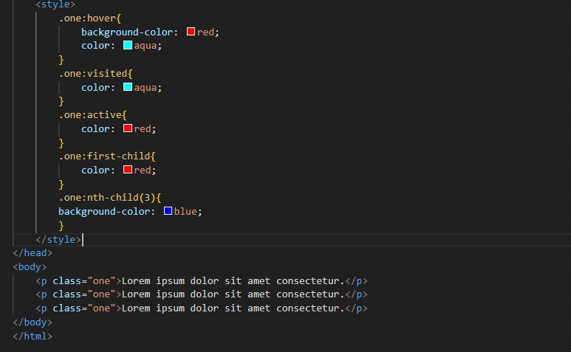

**Pseudo Element Selectoer :** A CSS pseudo-element is used to style specified parts of an element. For example, it can be used to: Style the first letter, or line, of an element. Insert content before,selection, or after, the content of an element.

A pseudo-class can be defined as a keyword which is combined to a selector that defines the special state of the selected elements. Unlike the pseudo-classes, the pseudo-elements are used to style the specific part of an element, whereas the pseudo-classes are used to style the element.

::first-letter (:first-letter) : It selects the first letter of the text.

::first-line (:first-line) :It styles the first line of the text.

::before (:before) :It is used to add something before the element's content.

::after (:after) :It is used to add something after the element's content.

::selection :It is used to select the area of an element that is selected by the user.

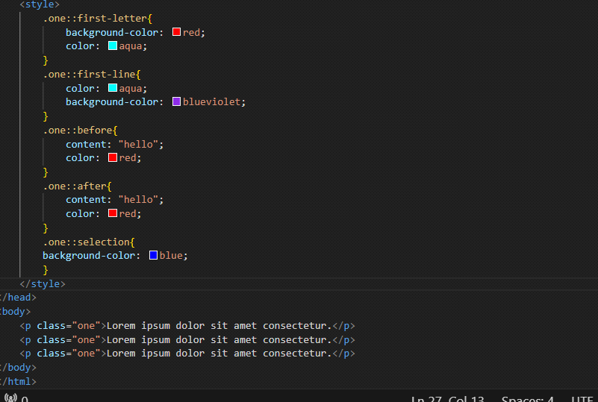

* 1. **:- What are the media types allowed by CSS?**

**Ans :-**

A Media query is a CSS3 feature that makes a webpage adapt its layout to different screen sizes and media types.

In the past, building a website was much simpler. Today a website’s layout should adapt itself not only to computers, but also tablets, mobile devices.

Media Query is a popular technique that enables to deliver a style sheet to different devices which have different screen sizes and resolutions respectively. They are used to customize the appearance of a website on multiple devices. A media query consist of a media type that can contain one or more expression which can be either true or false. The result of the query is true if the specified media matches the type of device the document is displayed on. If the media query is true then the style sheet is applied.

The screen resolutions of different devices are listed below:

1) Mobile (Smartphone) max-width: 450px

2) Low Resolution Tablets and ipads max-width: 720px

3) Desktops max-width:1280px

For example, when I want to select only screens, I will set the screen keyword right after the @ media rule. I also must concatenate the rules with the “and” keyword:

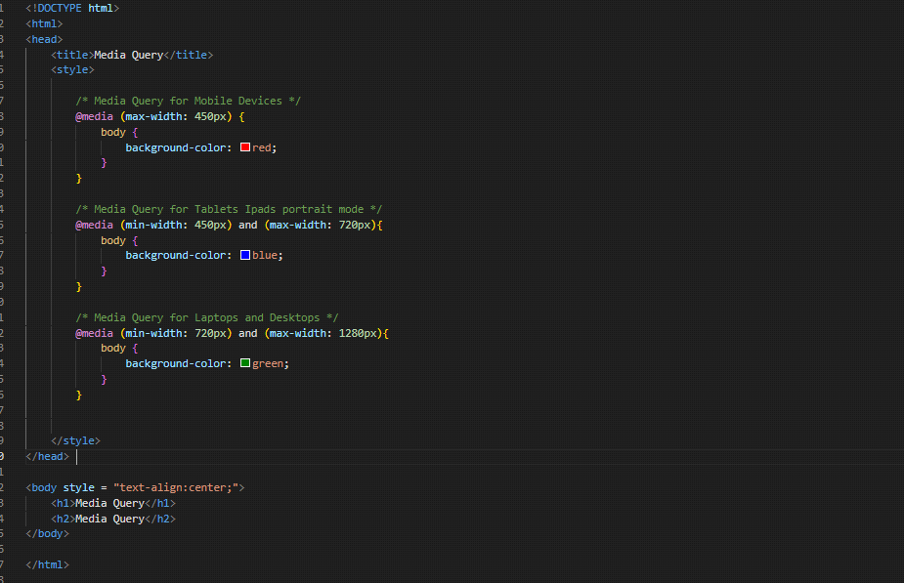

* 1. **:- What is the rule set?**

**Ans :-**

A CSS rule set contains one or more selectors and one or more declarations. The selector(s), which in this example is h1 , points to an HTML element. The declaration(s), which in this example are color: blue and text-align: center style the element with a property and value.

The “.” in the beginning indicates that the rule created will be a class, also “container” indicates the name of the selector. Similarly “first-child” indicates the pseudo-class, and elements inside curly brackets are elements of a declaration block, which contains some CSS properties and their corresponding values. The CSS ruleset will be applied when the selector name is called on the main HTML page.

But really, there are three important things to remember in the anatomy of a rule set: the selector, the property, and the value.

The selector is of 2 types, namely, id selector denoted by hash(#), used to apply the property having the unique id. The second is a class selector denoted by dot(.), used to select all elements which belong to a particular class attribute.

The key is property name & the value is property value, both the key and values are case-insensitive by default in CSS.

The portion in which the curly braces & the properties are declared is declaration block.

